
44th Nottingham Scouts
Information on Shooting

Thank you for enquiring about shooting at the 44th Nottingham Scouts, below is information you will need.

Shooting for adults is £5.00pp for the 2-hour session (Adult Groups on either range).
Payment on the night please.

6-yard Range
Explorers, Scouts, Guides, Brownies or Cub groups (12 maximum)
£48.00 each session. (£4.00 per child if the maximum of 12 attends)
Shoot Night 1 session, Master at Arms 3 Sessions
Payment on the night or via our website: www.basfordscouts.org.uk/shooting.html

10 metre Range
Explorers, Scouts or Guides holding a Master at Arms Badge/Sports Badge (for Guides) gained in shooting (15 Maximum).
£60.00 each session. (£4.00 per child if the maximum of 15 attends)
As we need to ensure that all the children shooting have the appropriate Master at Arms badge, we ask for Payment on the night.

When you arrive.
We ask that all Scouts/Guides follow any directions given to them by our group leaders or an instructor.
The children will be given a safety talk before being allowed to shoot.
The attached Permission to Shoot Form must be completed for each child and be handed to a leader/instructor when you arrive.
Without this form a child will NOT be allowed to shoot.

Shooting is normally carried out on Thursday nights due to Instructor availability.
The times for shooting are 7:30—9:30pm.
We ask that you arrive about 7:20pm so that we can get started on time.
Shoot nights can be as many nights as you wish. These nights are commonly used to introduce Cubs/Brownies/Scouts/Guides/Explorers/senior section to shooting.
The Scout Master at Arms course requires 3 sessions (usually 3 consecutive weeks)
For the Brownies sports badge we give you three weeks training towards your 6 weeks of participation; the additional 3 weeks can be done as separate sessions.
For the Explorers Master at Arms course these 3 sessions are usually spread over 4 or 5 weeks, leaving a gap after session 2.
Explorers and Scouts with a valid Master at Arms badge gained in shooting can book our larger range.


Nottingham Scouts
Permission to Shoot Form

I hereby give my consent that __________________________ is able to participate in the shooting of air rifles and air pistols under supervision of the qualified instructors of the City of Nottingham District.

Air Rifle Authorisation
Signature___________________ Print Name______________________ Date_____________

Extracts from Firearms Act 1968 (must be signed)
(Section 21)
1. A person who has been sentenced (to custody for life or) to preventative detention, or to imprisonment, or to corrective training for a term of three years or more (or to youth custody (or detention in a young offenders institution) for such a term, or who has been sentenced to be detained for such a term in a young offenders institution in Scotland, shall not at any time have a firearm or ammunition in their possession.

A person who has been sentenced…..to imprisonment for a term of three months or more but less than three years (or to youth custody (or detention in a young offenders institution) for such a term),or who has been sentenced to be detained for such a term in a detention centre or a young of-fenders institution in Scotland, shall not at any time before the expiration of the period of five years from date of release have a fire arm or ammunition in their possession.

This means:
Section 21 prohibits the possession of a firearm and ammunition (under any circumstances), by any person who has been convicted of a crime and sentenced to a term of imprisonment (or its equivalent for a young persons) of 3 months or more. The prohibition applies in all circumstanc-es, including handling and firing at an approved shooting club or at a clay pigeon shoot where a certificate is not ordinarily required. It also applies to the possession or use of other categories of firearms and ammunition such as AIRGUNS or shot cartridges for which a certificate is not needed.
A sentence of 3 months or 3 years attracts a five-year prohibition, shorter ones no prohibition but a longer one means a life ban.

I, being the parent / guardian of the person named above declare that he/she is not subject to restriction by virtue of the regulations set out in section 21 of the Firearms Act 1968
(extract printed above) and hereby give permission for _________________________to take part in the Activity of Shooting.
Signed:_________________________________ dated:_____________________________
Participants Cub/Scout/Explorer Group
_______________________________________________________Age of Participant _________

HOW TO FIND US
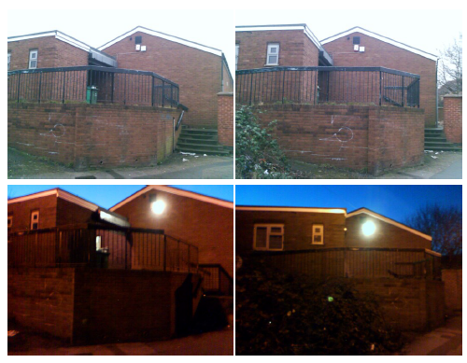
View of Scout Hall from the road.

Lincoln Street, Old Basford, Nottingham

WE ARE HERE!
One way system:
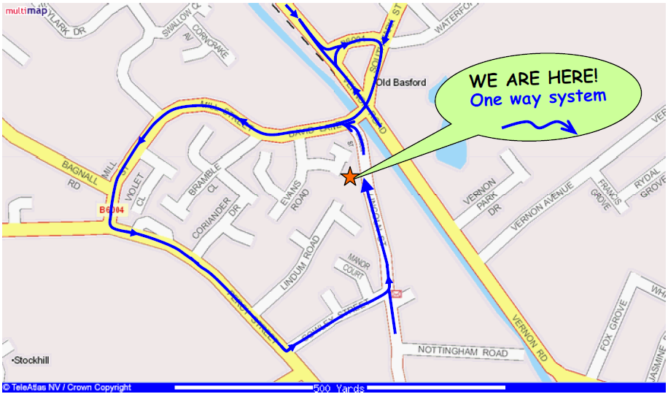
Grid ref: SK550432 X:455000m Y:343300m
Lat: 52:59:02N (52.9838) Lon: 1:10:56W (-1.1822)

